### Auto Switch

#### General

Under auto switch you can automate some of the actions of I/O in a decent easy manner, without knowledge of PLC programming. It is used to make small automations within the program.

#### Autoswitch Method

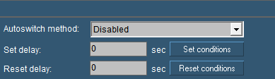

Figure 11‑19: Autoswitch

|  |  |
| --- | --- |
| **Autoswitch option** | **Explanation** |
| Autoswitch Method | Here you choose how the switch works  Disabled: not working  Set over Reset: Set is standard position  Reset over Set: Reset is standard position  Mimic Switch: for use in a mimic without attached sensor |
| Set Delay | Delay time for Set condition |
| Reset Delay | Delay time for Reset condition |
| Set conditions | Set conditions on how to react (see Figure 11‑20) |
| Reset conditions | Set conditions on how to react (see Figure 11‑20) |

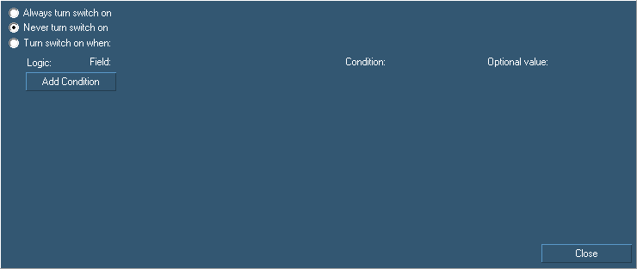

Figure 11‑20: Auto Switch Conditions

|  |  |
| --- | --- |
| **Autoswitch conditions** | **Explanation** |
| Always turn switch on | Switch is always on/visible |
| Never turn switch on | Switch is always off/unvisible |
| Turn switch on when | Let you add logic to turn a switch on |
| Add Condition | Alter the conditions that you need to make the switch work |

For example if you have a switch that turns on the bilge pump, you can also let it switch on when a certain event occur. So if you have a high alarm from that bilge, you can make the switch go on by saying so in the conditions field (see Figure 11‑21)

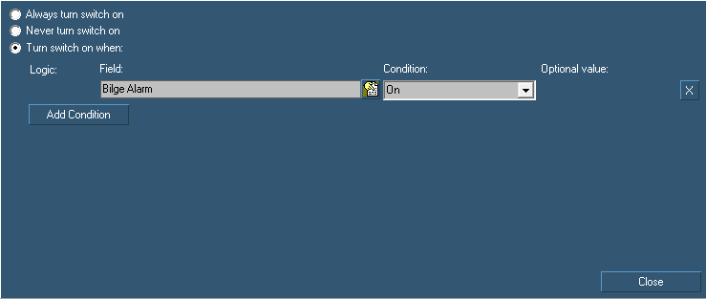

Figure 11‑21: Auto Switch condition

: under conditions you find a lot of possibilities where you can experiment to get the right adjustments you need. For some of those you can refer to chapter 12.10.3.